CPP Lecture Assignments 2:
/*1:Write a program that accepts numbers continuously as long as the number is positive and prints the sum of the given numbers. */
#include<iostream>
using namespace std;
int main(){
int n, sum=0;
do
{
cout<<"Enter the number: ";
cin>>n;
if(n<0){
break;
}
else{
sum += n;
cout<<"Sum is: "<<sum<<endl;
}
} while (n > 0);
return 0;
}
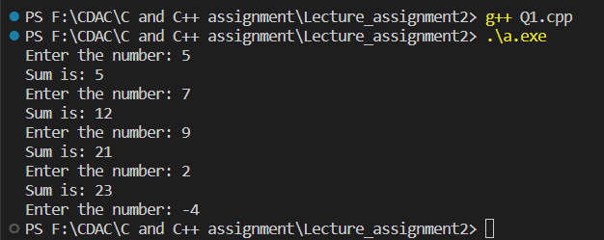

// 2. Write a program to accept two integers x and n and compute x raised to n.
#include<iostream>
using namespace std;
int main(){
int x, n, prod = 1, temp;
cout<<"Enter x value: ";
cin>>x;
cout<<"\nEnter n value: "<<endl;
cin>>n;
temp = n;
while(n != 0){
prod *= x;
--n;
}
cout<<x<<" raised to "<<temp<<" is: "<<prod<<endl;;
return 0;
}
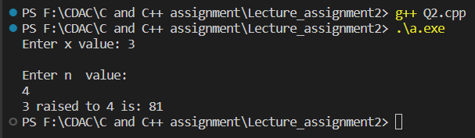

// 3. Write a program to accept a character, an integer n and display the next n characters.
#include<iostream>
using namespace std;
int main(){
int n;
char ch;
cout<<"Enter the character: ";
cin>>ch;
cout<<"\nEnter the n value: ";
cin>>n;
ch++;
while (n != 0)
{
cout<<ch<<endl;
ch++;
n--;
}
return 0;
}
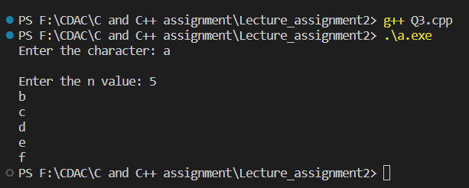

/*4. Write a program to calculate factorial of a number. For e.g. factorial of 5 = 5! = 5 *4*3*2*1 = 120*/
#include<iostream>
using namespace std;
int fact(int n){
if(n == 0){
return 1;
}
else{
return n * fact(n-1);
}
}
int main(){
int no;
cout<<"Enter the no.: ";
cin>>no;
cout<<"Factorial of "<<no<<" is "<<fact(no)<<endl;
return 0;
}
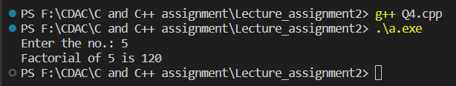
// 5. Write a program to calculate factors of a given number.
#include<iostream>
using namespace std;

int main(){
int no, factor;
cout<<"Enter the no.: ";
cin>>no;
cout<<"\nFactors of "<<no<<" are :";
for(int i=1; i<=no; i++){
if(no % i == 0){
cout<<i<<" ";
}
}
return 0;
}
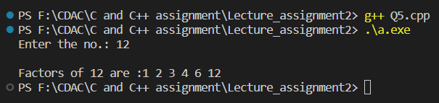
// 6. Accept two numbers and calculate GCD of them.
#include<iostream>
using namespace std;

int main(){
int no1, no2, gcd;
cout<<"Enter no1.: ";
cin>>no1;
cout<<"\nEnter no2.: ";
cin>>no2;
for(int i = 1; i <= no1 && i <= no2; i++){
if(no1 % i == 0 && no2 % i == 0){
gcd = i;
}
}
cout<<"GCD of "<<no1<<" and "<<no2<<" is "<<gcd;
return 0;
}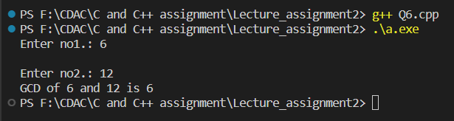
/*7. Write a menu driven program to do following operations :
a) Compute area of circle
b) Compute area of rectangle
c) Compute area of triangle
d) Exit
Display menu, ask choice to the user, depending on choice accept the parameters and perform the operation. Continue this process until user selects exit option.
*/
#include<iostream>
using namespace std;

int main(){
int radius, length, breadth, base, height, choice;
float area;
do{
cout<<"1. Compute area of circle."<<endl;
cout<<"2. Compute area of rectangle."<<endl;
cout<<"3. Compute area of triangle."<<endl;
cout<<"4. Exit"<<endl;
cout<<"Enter your choice: ";
cin>>choice;
switch (choice)
{
case 1:
cout<<"\nEnter radius of circle: ";
cin>>radius;
area = 3.14 * radius * radius;
cout<<"\nArea of circle is: "<<area<<endl;
break;
case 2:
cout<<"\nEnter length of rectangle: ";
cin>>length;
cout<<"\nEnter breadth of rectangle: ";
cin>>breadth;
area = length * breadth;
cout<<"\nArea of rectangle is: "<<area<<endl;
break;
case 3:
cout<<"\nEnter base of triangle: ";
cin>>base;
cout<<"\nEnter height of triangle: ";
cin>>height;
area = 0.5 * base * height;
cout<<"\nArea of triangle is: "<<area<<endl;
break;
case 4:
cout<<"Exit"<<endl;
break;
default:
cout<<"Invalid choice"<<endl;
break;
}
}while(choice != 4);
return 0;
}
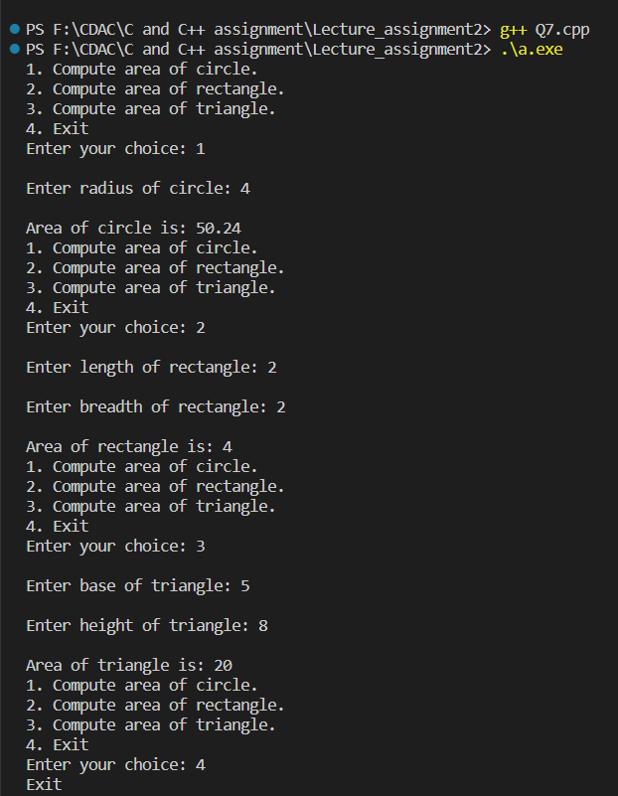

// 8. Write a program to print all prime numbers between 1 to n
#include<iostream>
using namespace std;

bool isPrime(int n){
if(n == 1 || n == 0){
return false;
}
for(int i = 2; i<=n/2; i++){
if(n % i == 0){
return false;
}
}
return true;
}
int main(){
int n;
cout<<"Enter the number: ";
cin>>n;
for (int i = 1; i <= n; i++)
{
if(isPrime(i)){
cout<<i<<endl;
}
}
return 0;
}
